
HEALTH, SAFETY & ENVIRONMENT MANAGEMENT SYSTEM
DAN Construction Safety Manual (DCSM)
Signage, Barrication and Traffic Control

Document Control
Document No. | 01-000001-000000-DAN-HSE-PRC-000021 | Revision | R01
Issue Date | June 2026 | Classification | Controlled — Internal
Document Owner | HSE Department | Page Format | US Letter

Table of Contents

1. Purpose
2. Scope
3. References
4. Deliverable
5. Signs and Labels
6. Barricades
6.1 Barricade Tape Colours
6.2 Fencing and Heavy-Equipment Barricades
7. Signalling and Flaggers
8. Project Traffic Control Plan
9. Training
10. Records
11. Related Documents
Figures and Illustrations
Revision History

1. Purpose
This document describes the DAN requirements for signs, labels, barriers, signals and traffic control during construction.
Note: This document does not address KSA transportation and traffic-control requirements. Where available, GHS signs shall be used so signage is universally understood, and signage shall be translated into the dominant site languages where possible.

2. Scope
This document applies to all DAN construction sites requiring signage, barricades, and traffic control to protect personnel, the public and the travelling public.

3. References
- KSA Ministry of Transport (MOT) and Civil Defence guidelines
- DCSM — Hazard Communication
- DCSM — Emergency Planning and Response

4. Deliverable
- Project Traffic Control Plan.

5. Signs and Labels
Note: Signs shall be printed in English, Arabic and the site language(s) of the majority of the workforce.
Signs are used to point out hazardous conditions, warn people to proceed with caution, or provide instruction, direction or information — for example at lift operations, flammable storage, abatement and blasting locations, energised circuits, unstable excavations, confined spaces, equipment under repair and exits. The following sign conventions apply:
Sign Type | Predominant Colour | Use
DANGER | Red | Where an immediate hazard exists.
CAUTION | Yellow | To warn against potential hazards or unsafe practices.
Informational | Blue | To convey general information.
Safety Instruction | White with green panel | Principal safety message (white letters on green; additional wording in black).
EXIT | Distinctive / contrasting | Legible letters greater than 6 in. high, contrasting with surroundings.
Signs shall be short and easy to read, lighted or reflectorised where needed at night, removed when the condition is eliminated, and supplemented by accident-prevention tags as a temporary warning (tags do not replace signs). Specific hazard signs identify RF radiation, lasers and ionising-radiation sources; hazardous-material containers are labelled per the Hazard Communication chapter.

6. Barricades
- Designated persons specify the authorised personnel and required PPE to enter a barricaded area; barricades completely enclose more-hazardous areas and are placed no less than 6 ft from the hazard.
- Warning signs are used in conjunction with barricades; barricade equipment is not used for other purposes; barricades and signs are never removed without permission from the designated person.

6.1 Barricade Tape Colours
Tape / Rope | Meaning
Red tape | Imminent danger area — keep out.
Yellow tape or rope | Use caution before entering — proceed with caution.
Purple and yellow tape | Radiation area — keep out.

6.2 Fencing and Heavy-Equipment Barricades
- Provide temporary fencing as contractually required, posting construction-hazard warning signs every 300 ft (91 m); for areas of minimal public exposure, fencing is not required but warning signs are posted.
- Where the rotating superstructure of a crane, excavator or piling rig is less than 7 ft above ground, barricade the swing radius to visually alert personnel of the struck/crush hazard; crane barricades conform to a standard 42-in. handrail height.
- For equipment that frequently relocates, barricades may be attached to the equipment body to ensure availability and eliminate repeated set-up.

7. Signalling and Flaggers
- Flaggers (or other traffic controls) are used where signs, signals and barricades do not provide necessary protection from traffic; only trained, certified flaggers are assigned (untrained personnel only during emergencies until a certified flagger is available).
- Flagger signalling conforms to KSA Ministry guidelines using approved sign paddles or lights; a flagger wears a high-visibility vest, high-visibility hard hat and high-visibility pants (at night or low visibility).
- A three-sign advance-warning sequence is required on roadways below 45 mph, and four signs at 45 mph or higher, with MOT spacing; flagger workstations are floodlit at night without disabling glare.
- Flaggers are not assigned other duties while flagging, are prohibited from using distracting devices (cell phones, music players), and receive frequent breaks to remain alert.

8. Project Traffic Control Plan
Where flaggers are used on a job lasting more than one day, a Project Traffic Control Plan is enacted to move traffic safely through or around the construction zone. A qualified person develops and implements it per MOT and Civil Defence regulations; the Project Manager and SH&E Representative facilitate compliance, and the Competent Person oversees and monitors it. As a minimum, the plan includes the responsible qualified and designated persons, AHAs and daily huddles, inspection and training provisions, sign use and placement, pavement markings, scheduling, device placement and maintenance, flagger placement, roadway lighting and traffic regulations.

9. Training
Personnel are trained in caution and warning methods at initial assignment; supervisors identify additional training needs during the 2-week look-ahead and instruct personnel in recognising hazards identified by signs and barriers at daily huddles. Flaggers receive a jobsite orientation each time they are assigned to a new project or when conditions change significantly, with retraining on job/equipment changes or observed deficiencies; all training is recorded.

10. Records
The Project Traffic Control Plan, training records and inspection records are documented and maintained on-site for the duration of the project and archived at project close.

11. Related Documents
- DCSM — Hazard Communication
- DCSM — Emergency Planning and Response
- Project Traffic Control Plan Template
- Accident Prevention Tag

Figures and Illustrations
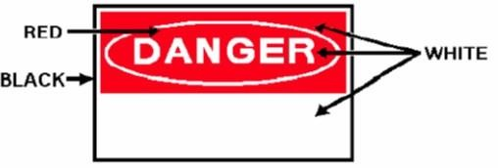
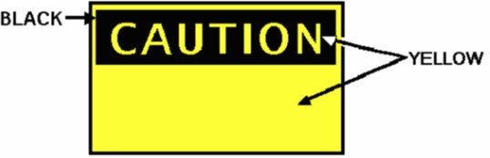
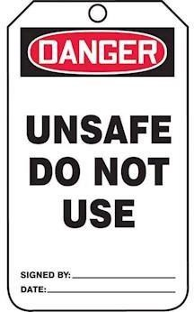
Figure 21-1 Accident
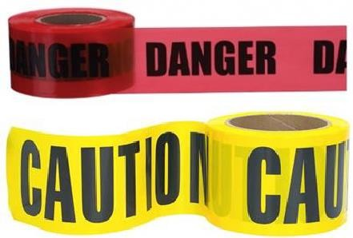
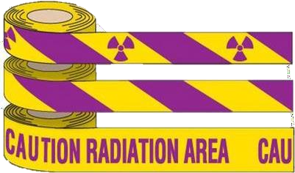

Revision History
Rev. | Date | Description of Change | Approved By
R00 | June 2026 | Initial issue. Restructured to the DAN integrated HSSE management-system template and re-branded in accordance with the DAN Brand Book. | Project Director
R01 | June 2026 | Re-coded to the updated DAN document-numbering convention (01-000001-000000-DAN-{discipline}-{type}-{seq}). | Project Director

